Postal Life Insurance

Department of Post

Software Requirements Specification (SRS)/ Functional Requirements Specification (FRS)
  - Chatbot

INTERNAL APPROVAL FORM

Project Name: Chatbot
Version: 1.0
Submitted on:
 | Name | Date
Approved By:
Reviewed By:
Prepared By:

VERSION CONTROL LOG
Version | Date | Prepared By | Remarks
1

Table of Contents

1. Executive Summary 4
2. Project Scope 4
3. Business Requirements 4
4. Functional Requirements Specification 4
4.1 Use Cases 1: Policy Status Inquiry 5
4.2 Use Cases 2: Premium Reminder 5
4.3 Use Cases 3: Premium Payment Links 6
4.4 Use Cases 4: Service Request Tracking 6
4.5 Use Cases 5: Loan/Surrender Value Checks 6
4.6 Use Cases 6: Registration and onboarding assistance 6
4.7 Use Cases 7: Guided claim submission and nomination updates 7
4.8 Use Cases 8: FAQ Handling 7
4.9 Use Cases 9: Escalation to Live Agent 7
5. Attachments 7

1. Executive Summary
The purpose of this document is to define the functional and non-functional requirements for the Chatbot Module in IMS. The chatbot will serve as a virtual assistant to help policyholders and stakeholders interact with the system for queries, service requests, and information retrieval.

2. Project Scope
This Module will:
- Provide 24x7 automated assistance via web and mobile platforms.
- Handle FAQs, policy status queries, premium due, and service request tracking.
- Integrate with IMS Core, CRM, and Notification Engine.
- Support multilingual interactions and escalation to human agents.

3. Business Requirements

ID | Requirements
FS_CB_001 | The chatbot shall provide instant responses to customer queries using a predefined knowledge base and FAQs.
FS_CB_002 | The chatbot shall retrieve and display real-time policy and premium information from IMS Core.
FS_CB_003 | The chatbot shall accept and track service requests initiated by users.
FS_CB_004 | The chatbot shall escalate unresolved or complex queries to live customer service agents.

4. Functional Requirements Specification

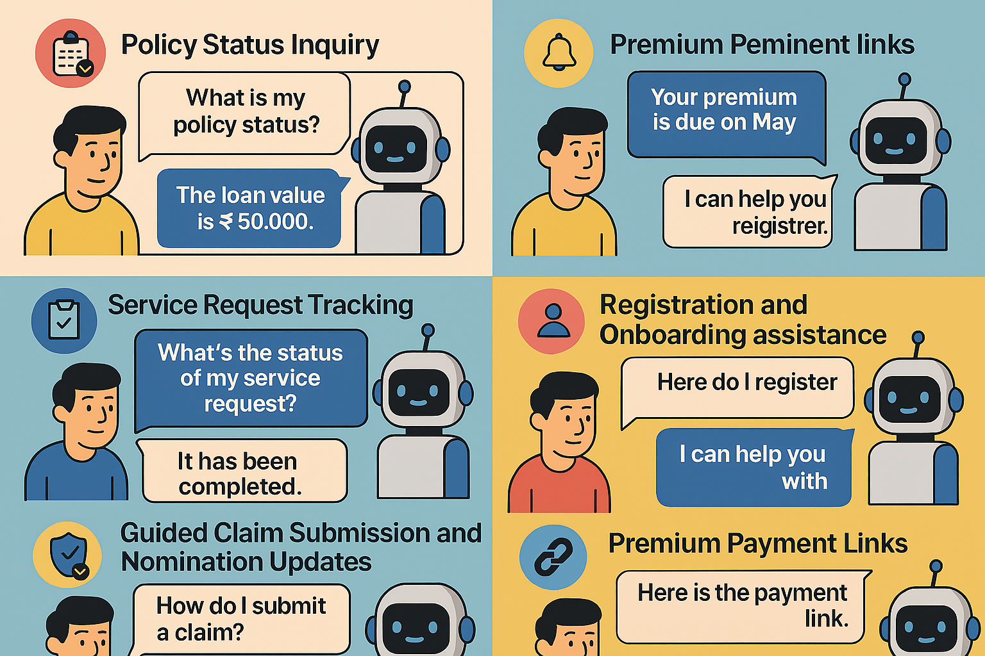

4.1 Use Cases 1: Policy Status Inquiry
- Actor: Policyholder
- Trigger: User asks “What is my policy status?”
- Flow:
  - Chatbot authenticates user via OTP.
  - Retrieves policy status from IMS Core.
  - Displays status and next premium due date.

4.2 Use Cases 2: Premium Reminder
- Actor: Policyholder
- Trigger: User asks “When is my next premium due?”
- Flow:
  - Chatbot verifies identity.
  - Fetches premium schedule.
  - Sends SMS/Email reminder if requested.

4.3 Use Cases 3: Premium Payment Links
- Actor: Policyholder
- Trigger: User asks “How should I pay the premium?”
- Flow:
  - Chatbot displays the premium payment links and disclose all the information including BBPS and other digital modes of payments with payment link in the chat.

4.4 Use Cases 4: Service Request Tracking
- Actor: Policyholder
- Trigger: User asks “What’s the status of my service request?”
- Flow:
  - Chatbot asks for request ID.
  - Retrieves status from service module.
  - Displays current status and expected resolution time.

4.5 Use Cases 5: Loan/Surrender Value Checks
- Actor: Policyholder
- Trigger: User asks “What’s the status of my service request?”
- Flow:
  - Chatbot asks for request ID.
  - Retrieves status from service module.
  - Displays current status and expected resolution time.

4.6 Use Cases 6: Registration and onboarding assistance
- Actor: Policyholder
- Trigger: User asks “How to buy Policy?”
- Flow:
  - Chatbot asks for Name, Mobile Number and EMail.
  - Send the data to Lead Management System.
  - Displays the Information and Link regarding Digital Onboarding and policy issue.

4.7 Use Cases 7: Guided claim submission and nomination updates
- Actor: Policyholder
- Trigger: User asks “How to process Claim?” or “How to add Beneficiary or Nominee”
- Flow:
  - Chatbot asks for Policy Number.
  - Displays steps for the Claim submission (Both Digital and Offline at Post Office) or for adding Nomination.

4.8 Use Cases 8: FAQ Handling
- Actor: Policyholder
- Trigger: User asks question similar to “How can I update my address?”
- Flow:
  - Chatbot matches query to FAQ database.
  - Provides step-by-step instructions or link to service form.

4.9 Use Cases 9: Escalation to Live Agent
- Actor: Policyholder
- Trigger: User asks “I want to talk to a person.”
- Flow:
  - Chatbot checks agent availability.
  - Transfers session to live chat.
  - Logs escalation event.

5. Attachments
The following documents can be referred.

